KOYEL GHOSH

STREAM-IT 3rd SEM

Roll No.-16500221044

Subject Code: PCC-CS392

Design carry look ahead Adder

* THEORY

To reduce the computation time, there are faster ways to add two binary numbers by using

carry lookahead adders. They work by creating two signals P and G known to be Carry

Propagator and Carry Generator. The carry propagator is propagated to the next level

whereas the carry generator is used to generate the output carry ,regardless of input carry.

* EQUATION

Design Issues:

The corresponding boolean expressions are given here to construct a carry lookahead adder.

In the carry-lookahead circuit we ned to generate the two signals carry propagator(P) and

carry generator(G),

Pi = Ai ⊕ Bi

Gi = Ai · Bi

The output sum and carry can be expressed as

Sumi = Pi ⊕ Ci

Ci+1 = Gi + ( Pi · Ci)

Having these we could design the circuit. We can now write the Boolean function for the

carry output of each stage and substitute for each Ci its value from the previous equations:

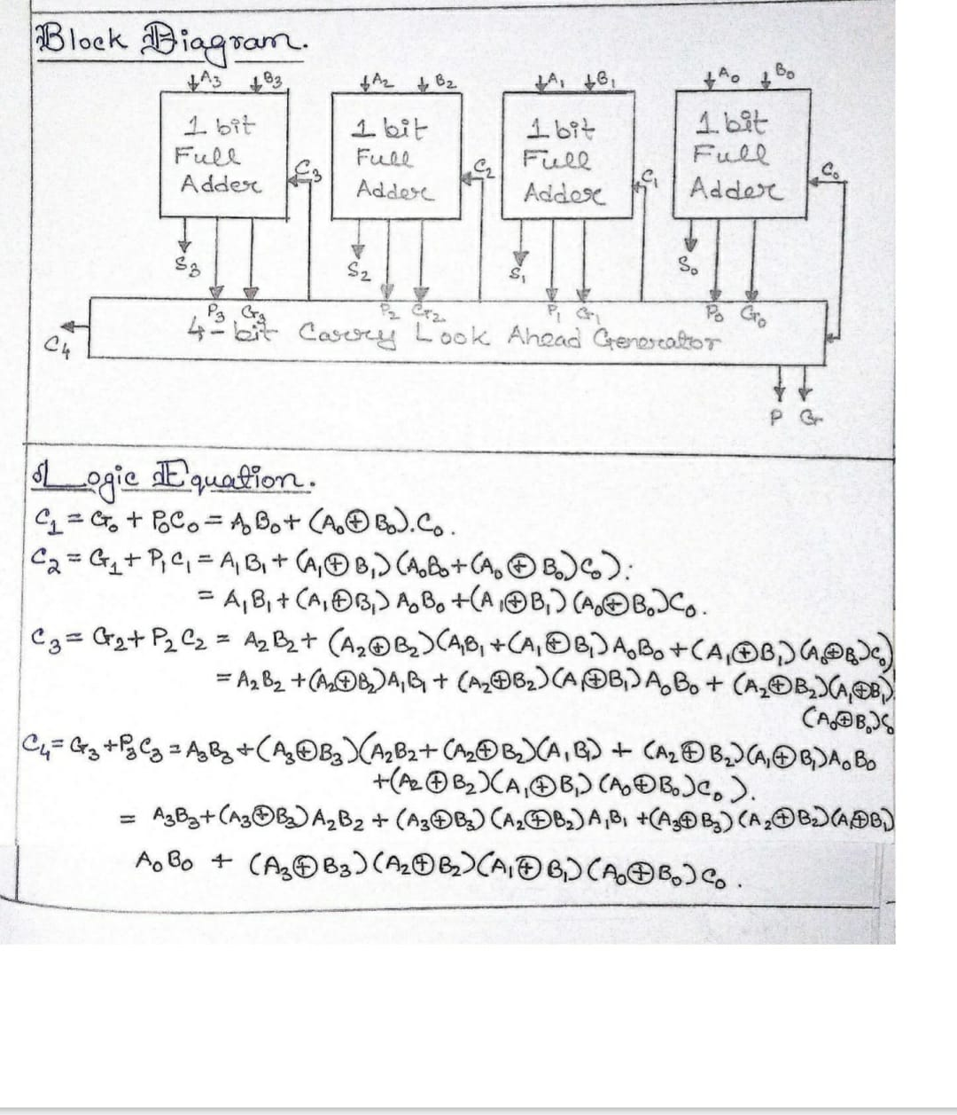

* CIRCUIT DIAGRAM

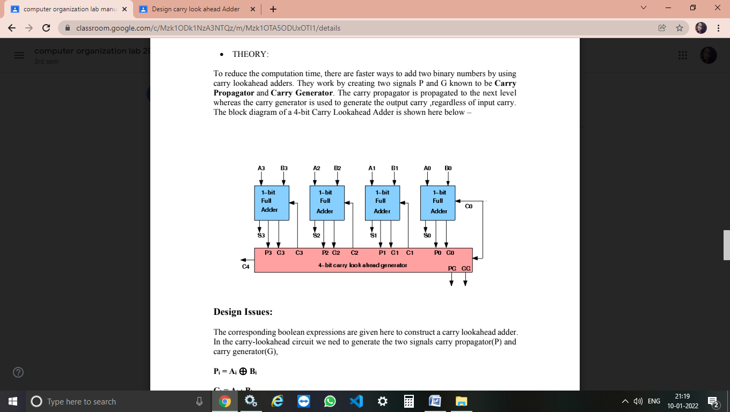

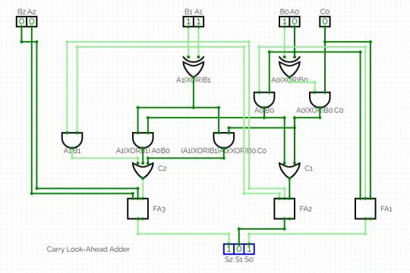

* RESULT & CONCLUSION

We get the following equation from the implemented circuit which is describe above and

We can further design carry look ahead Adder by the help of this methodology.